BOTBRAINS BATTLE

Real-World Rumble(Round-3)

Part(d)

-Mokshyada Mishra

**d)**Three drones are made autonomous and these drones move in the target specified location according to the code given to each drone, where the complete search of the specified location for the target and prevention of collision of any two drones are taken care of. Each drone has lidar sensor by which if they come in front of any object of height 15cm, then the drone stops and measures the other dimensions of the object. If the measurement taken by lidar sensor is 15cm for both the other dimensions, then that drone uses color sensor to detect the color and as the target color is specified as green, if the observed color by the color sensor attached is not green, then the drone again continue its journey of search until it encounters an object of height 15cm and checks the object by the above-mentioned mechanism. If the color sensed by color sensor is green in the above case, then it sends this information immediately to other drones through swarm technology. As the required task is accomplished the other two drones stop searching. The block diagram is shown below.  
As anyone of the drone finds the target it sends the information to other two drones.

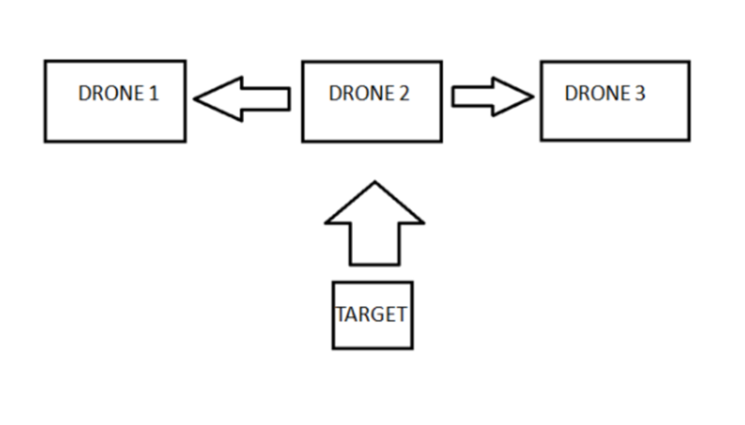

Pre-Requisites and Past Plots:

LIDAR (Light Detection and Ranging) uses laser pulses to measure distances, creating detailed 3D representations. It is used in autonomous vehicles for obstacle detection and mapping, in GIS for topographic mapping, in forestry for vegetation analysis, and in archaeology for site discovery. LIDAR aids in environmental monitoring like coastal erosion, in agriculture for precision farming, and in construction for site surveying and structural analysis.

IDEATION:

Objective:To make drones search a specified area for a target object, avoid collisions, and communicate findings using swarm technology.

Components:

1. Drones: Equipped with flight controllers, LIDAR, and color sensors.

2. Sensors:

a)LIDAR: Measures object dimensions and detects obstacles.

b)Color Sensor: Identifies object colors.

3. Communication:

Swarm Technology: Allows drones to share information about the target.

**Steps and Considerations:**

1. Initialization:

- Flight Controller: Setingup the drone's flight system.

- Sensors: Initialising LIDAR and color sensors.

- Communication: Establishing swarm communication protocol.

2. Autonomous Navigation:

- Flight Path: Coding drones to navigate a predefined path.

- Collision Avoidance: Using LIDAR to detect obstacles and avoid collisions.

3. Object Detection:

- Height Measurement: Using LIDAR to measure height. If 15 cm, proceed.

- Dimension Check: Measuring width and depth. If both are 15 cm, checking color then.

4. Color Detection:

- Target Color: Using color sensor. If green, identify as target object.

5. Communication in Swarm:

- Message: If target found, sending message to other drones.

- Stop Search: Other drones stop searching upon receiving the message.

6. Testing and Validation:

- Simulation: Test code in a simulated environment.

- Field Test: Test in real-world conditions.

**Tools and Technologies:**

- Programming Language: C++ with Arduino libraries.

- Hardware: ESP8266 microcontroller, LIDAR sensors, color sensors, and flight controllers.

- Software: Arduino IDE for coding and debugging.

**Hardware Required:**

1. Flight Controller (e.g., Pixhawk)
2. LIDAR Sensors (e.g., LIDAR-Lite v3)
3. Color Sensors (e.g., TCS34725)
4. Communication Modules (e.g., ESP8266)
5. Power Source (Li-Po battery)
6. Other necessary components like ESCs, motors, propellers, GPS, etc.

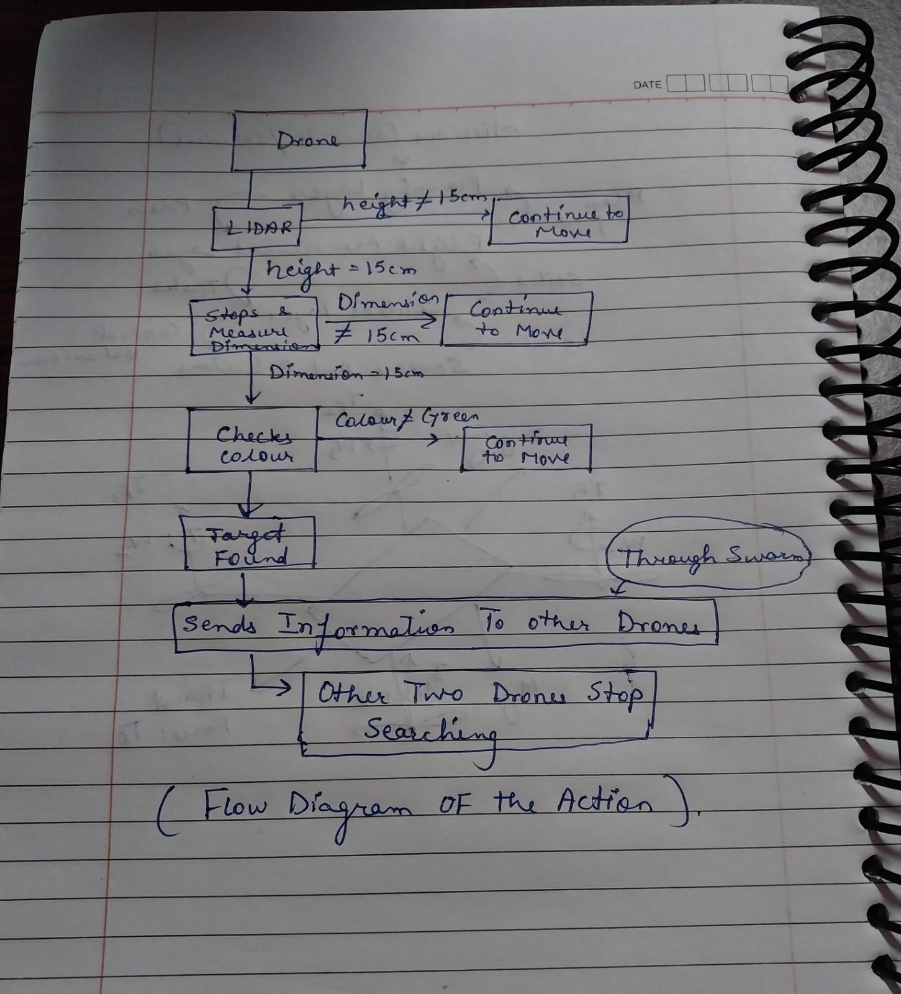

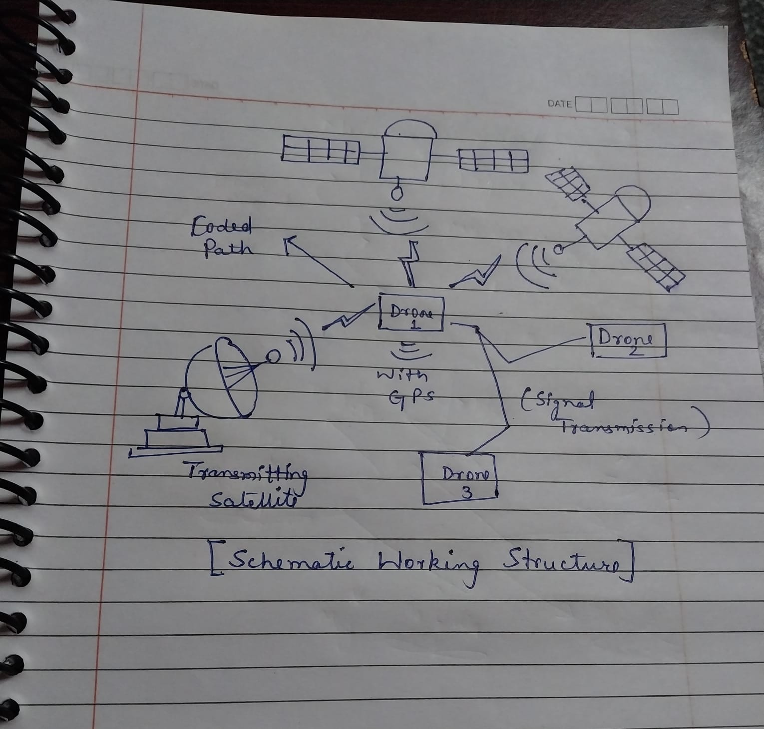

**CODE FEATURES AND UNIQUENESS:**

1) **Multi-Sensor Integration**:

* Combines LIDAR and color sensors to detect and identify target objects by dimensions and color.

2) **Swarm Communication**:

* Uses swarm tech for drones to share info, improving search efficiency.

3) **Autonomous Navigation**:

* Drones navigate and avoid obstacles using real-time LIDAR data.

4) **Dynamic Task Allocation**:

* Adjusts drone tasks based on real-time findings to optimize search efforts.

5) **Real-Time Processing**:

* Processes sensor data instantly for immediate decision-making.

6) **Robust Testing**:

* Can be Tested in simulated and real-world environments for reliability.

7)**MOST IMPORTANT:**

**Use of Mock Classes:**

Mock classes in this context are simplified, simulated versions of actual hardware interfaces. These mock classes are designed to provide the basic functionality needed for testing and development without requiring actual hardware and return a fixed value.

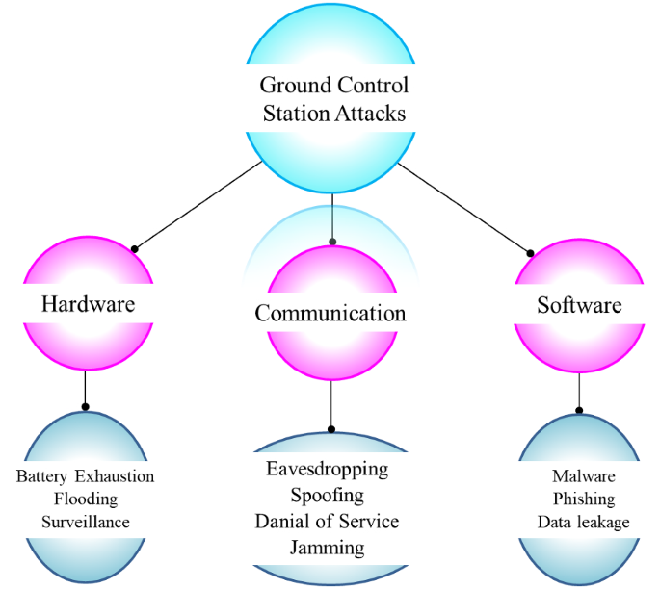

**Limitations:**

1)Sensor Limitations:

- LIDAR Accuracy: LIDAR sensors might be less accurate in bad weather (rain, fog, dust).

- Color Sensor Reliability: Varying light conditions, shadows, and reflective surfaces can cause false positives or negatives.

2)Communication Issues:

- Range and Interference: Limited communication range, with interference from other devices or obstacles affecting signal quality.

- Latency: Message transmission delays could affect drone synchronization in real-time.

3)Battery Life

4)Environmental Factors

5)Collision Avoidance:

- Dynamic Obstacles: Difficulty avoiding moving obstacles (e.g., vehicles, people) as the system relies on static LIDAR measurements.

6)Algorithm Efficiency: Complex algorithms for collision avoidance and search can cause processing delays.

7)Initial Cost can be High

**CONCLUSION:**

This project aims to enhance the capabilities of autonomous drones by integrating advanced sensing and communication technologies. By successfully implementing the code, the drones will efficiently search for and identify target objects, avoid collisions, and communicate findings, making them useful for a variety of applications such as search and rescue, environmental monitoring, and security surveillance.

References:1) Springer:[Unmanned aerial vehicles (UAVs): practical aspects, applications, open challenges, security issues, and future trends | Intelligent Service Robotics (springer.com)](https://link.springer.com/article/10.1007/s11370-022-00452-4)

2)MDPI Path Planning For Autonomous drones:<https://www.google.co.in/url?sa=t&rct=j&q=&esrc=s&source=web&cd=&cad=rja&uact=8&ved=2ahUKEwjAyrGUmOWGAxX1SGwGHZ6iAYQQFnoECB8QAQ&url=https%3A%2F%2Fwww.mdpi.com%2F2504-446X%2F7%2F3%2F169&usg=AOvVaw1Vrx_B9yUzk8kJDW5S0CrT&opi=89978449>